Tansley Residence

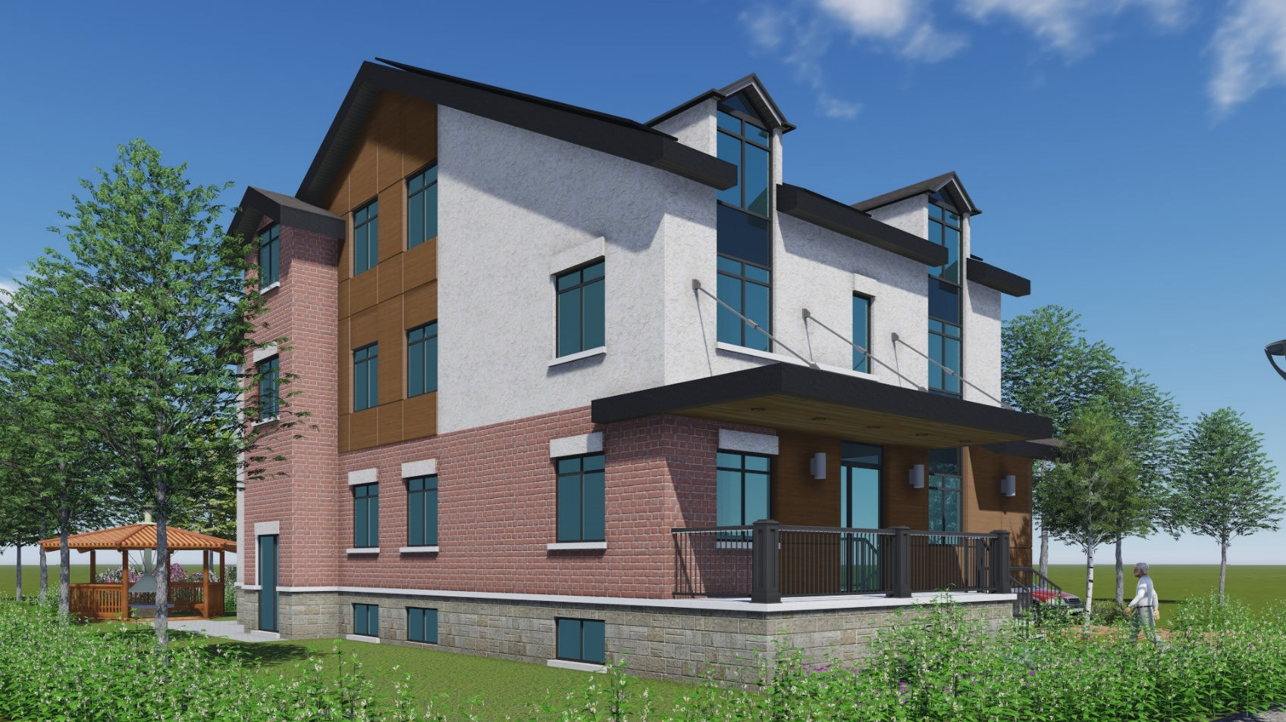Complex care residence for 7 individuals with individual bedrooms/bathrooms and common spaces.

# C:\Users\salbione\OneDrive - Reena\J Drive on One Drive\Batay Reena\Tansley\Drawings\10.jpg